**Operating Systems – COC 3071L**

# SE 5th A – Fall 2025 Part 1: File and Directory Operations

1. Create the following directory structure in your home directory:

Lab

_

3

/

├──

do

c

s

/

│

└──

dr

a

fts

/

├──

d

a

t

a

/

│

├──

r

a

w

/

│

└──

pro

c

essed

/

└──

s

c

ripts

/

2

.

Inside

do

c

s

/

:

Create three files:

intro

.

txt

,

notes

.

txt

,

summ

a

ry

.

txt

.

Add at least

**two lines of text**

into each using

e

c

ho

>>

.

Copy

summ

a

ry

.

txt

into the

dr

a

fts

/

folder using

c

p

command.

3

.

Inside

d

a

t

a

/

r

a

w

/

:

Create two files:

r

a

w

1

.

txt

,

r

a

w

2

.

txt

.

Append the

**current date**

into

r

a

w

1

.

txt

using the

d

a

te

command.

Move

r

a

w

2

.

txt

into

pro

c

essed

/

using

mv

. The syntax is:

mv

sour

c

e

destin

a

tion

4

.

Inside

s

c

ripts

/

:

Create a script named

hello

.

sh

with the following content:

e

c

ho

"

H

ello

W

orld

"

pwd

ls

-

lh

Later, you will make it executable (in Part 3).

5

.

Display the directory structure recursively and take a screenshot:

ls

-

R

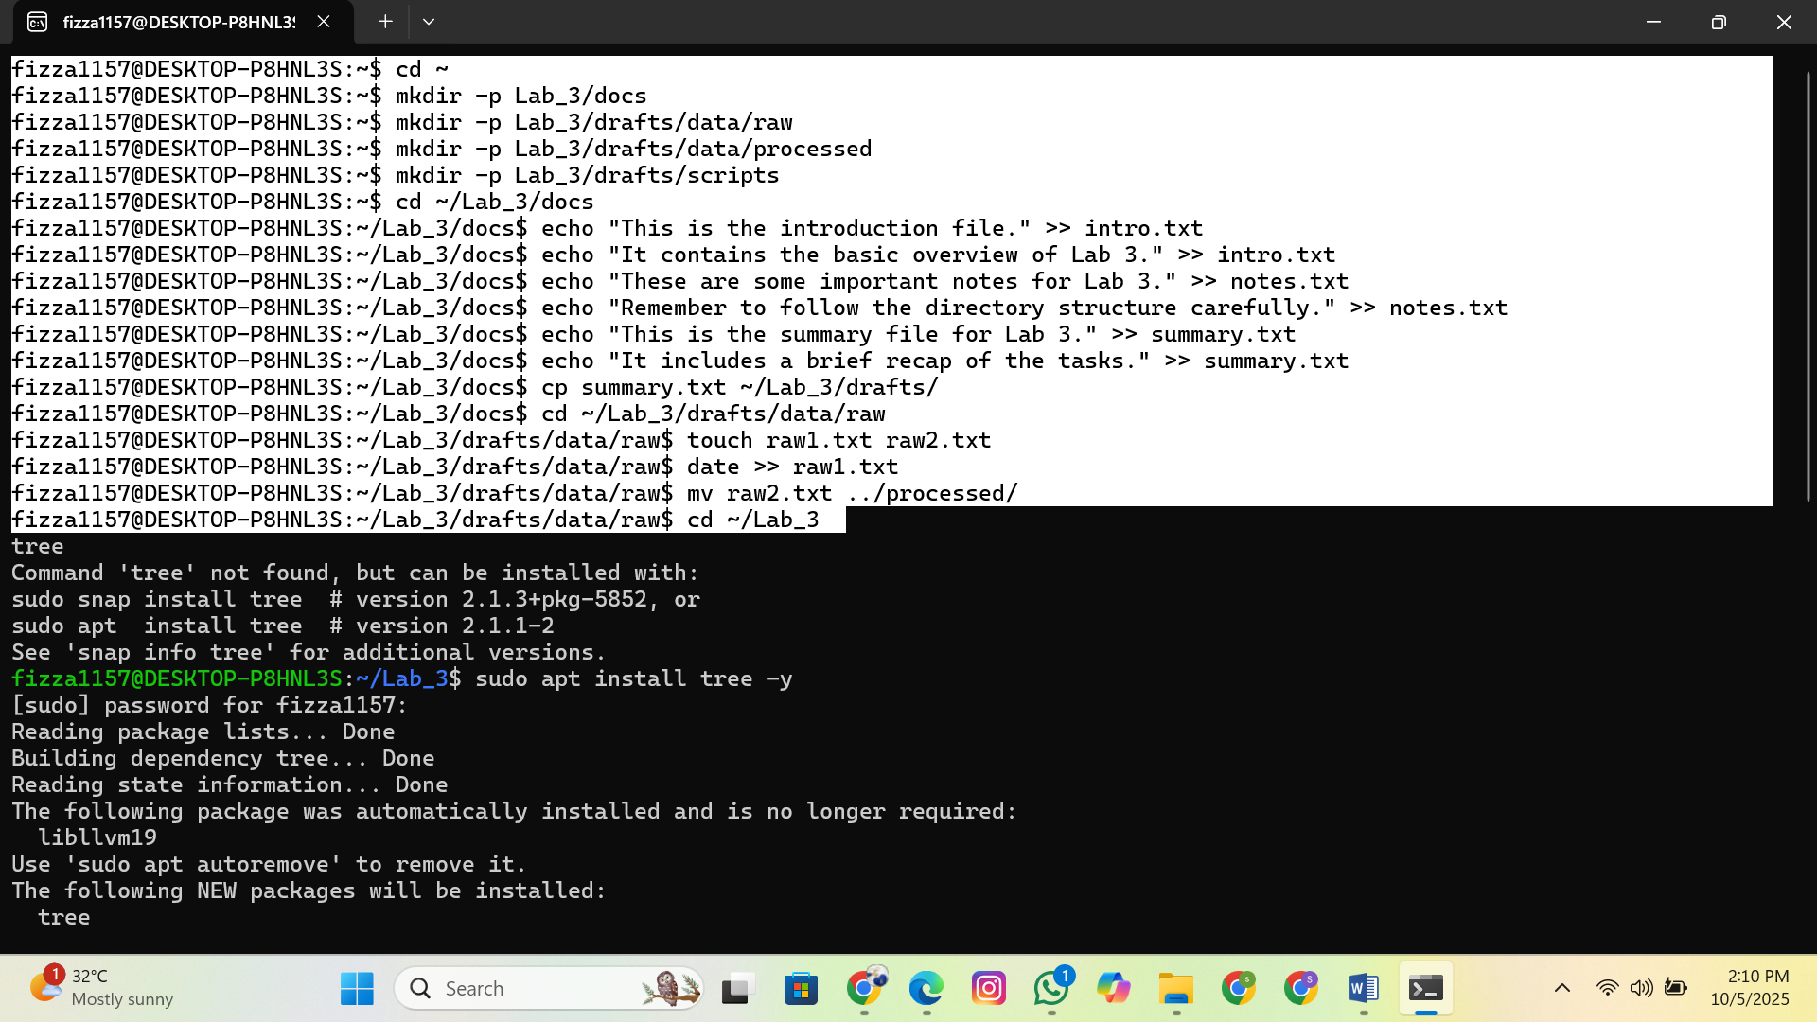

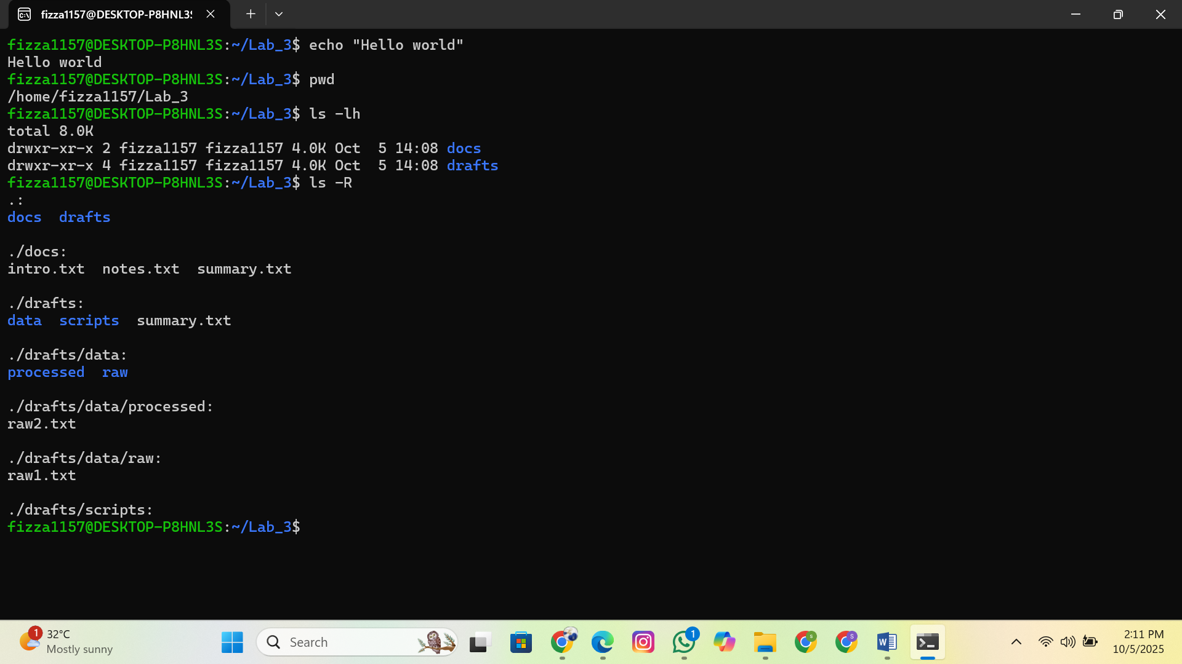

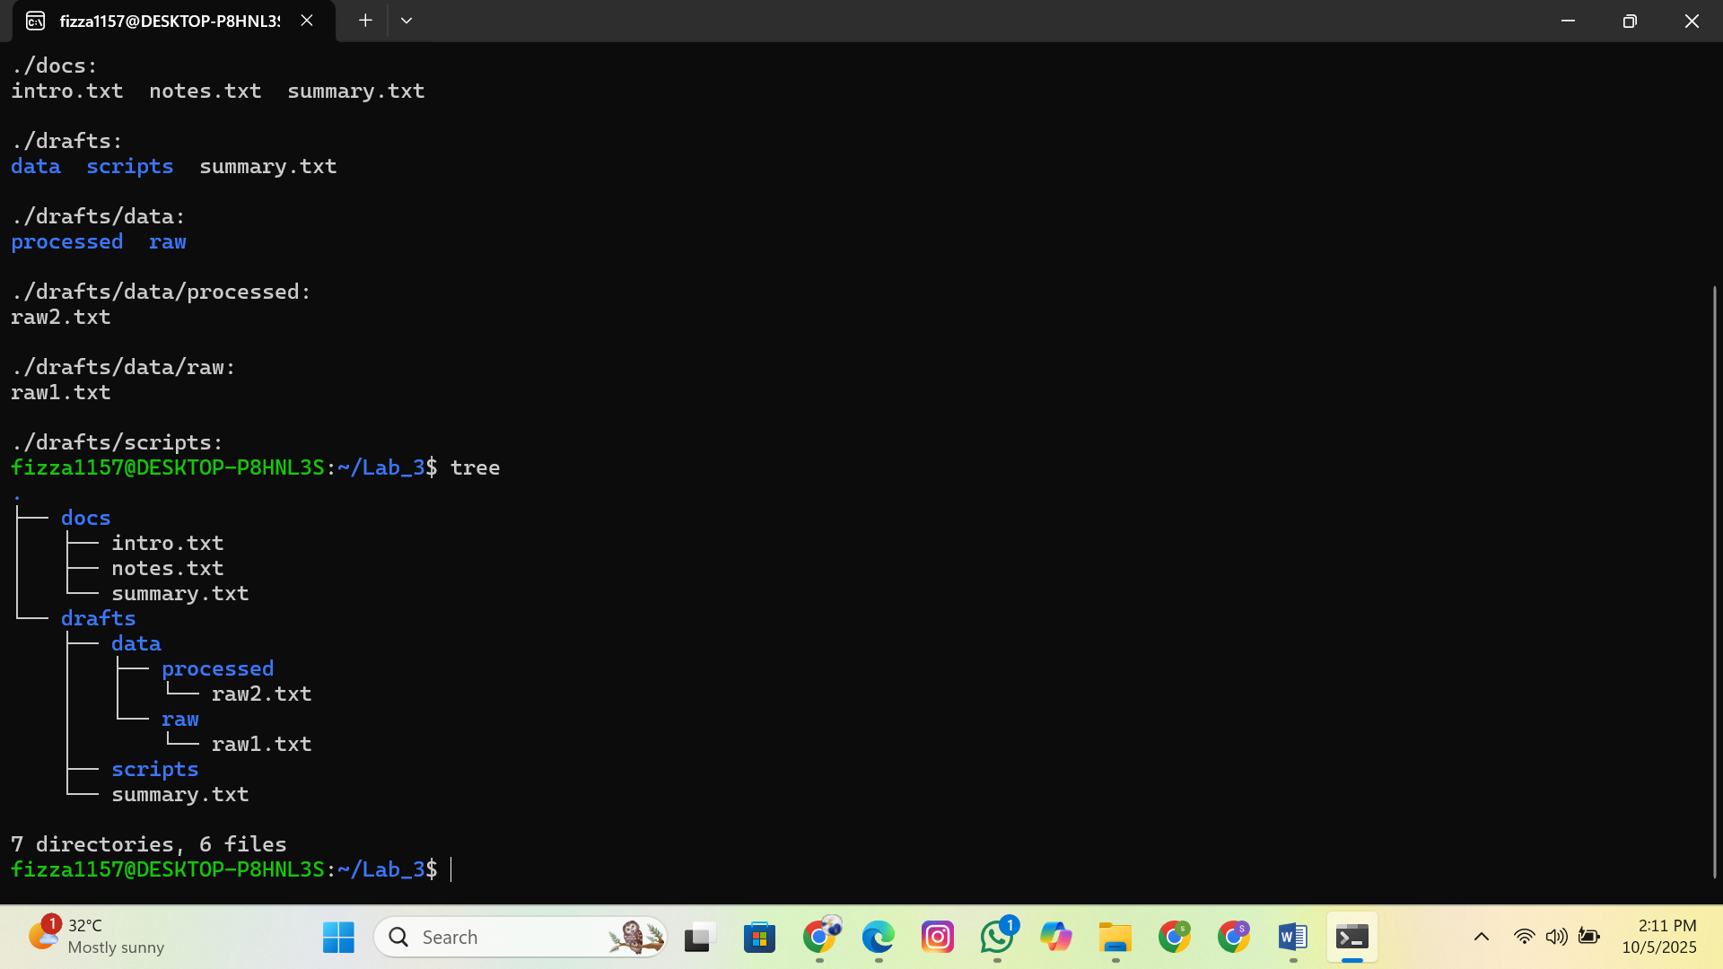

# Part 2: Practice with Basic Linux Commands

Run the following commands inside Lab_3/ and note their outputs:

pwd → Show current working directory.

whoami → Display the current logged-in user. touch extra.txt → Create an empty file. cat intro.txt → Display file contents. rm extra.txt → Delete a file.

history | tail -n 5 → Show your last 5 executed commands. clear → Clear the terminal.

Take screenshots of commands and outputs.

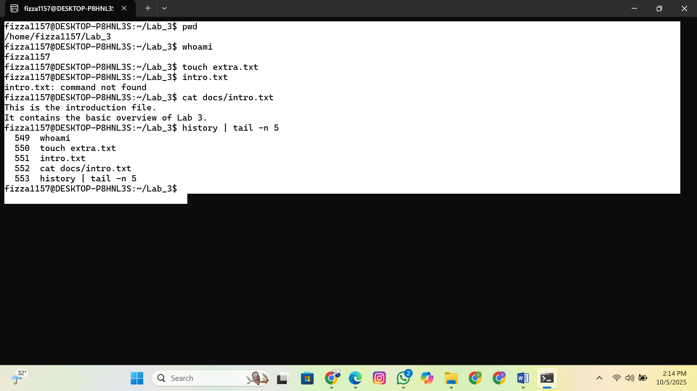

# Part 3: File Permissions and Ownership

1

.

Change the permissions of

hello

.

sh

so that:

Owner → Read, Write & Execute

Group → Read, Write & Execute

Others → No permissions

Run the script using:

./

hello

.

sh

Take a screenshot of its output.

1. Change the permissions of intro.txt using **numeric notation** so that:

Owner → Read & Write

Group → Read & Write

Others → Read only

1. Change the permissions of notes.txt using **symbolic notation** so that others don't have any permission on it.
2. Verify all changes with:

ls

-

l

Take a screenshot of the output.

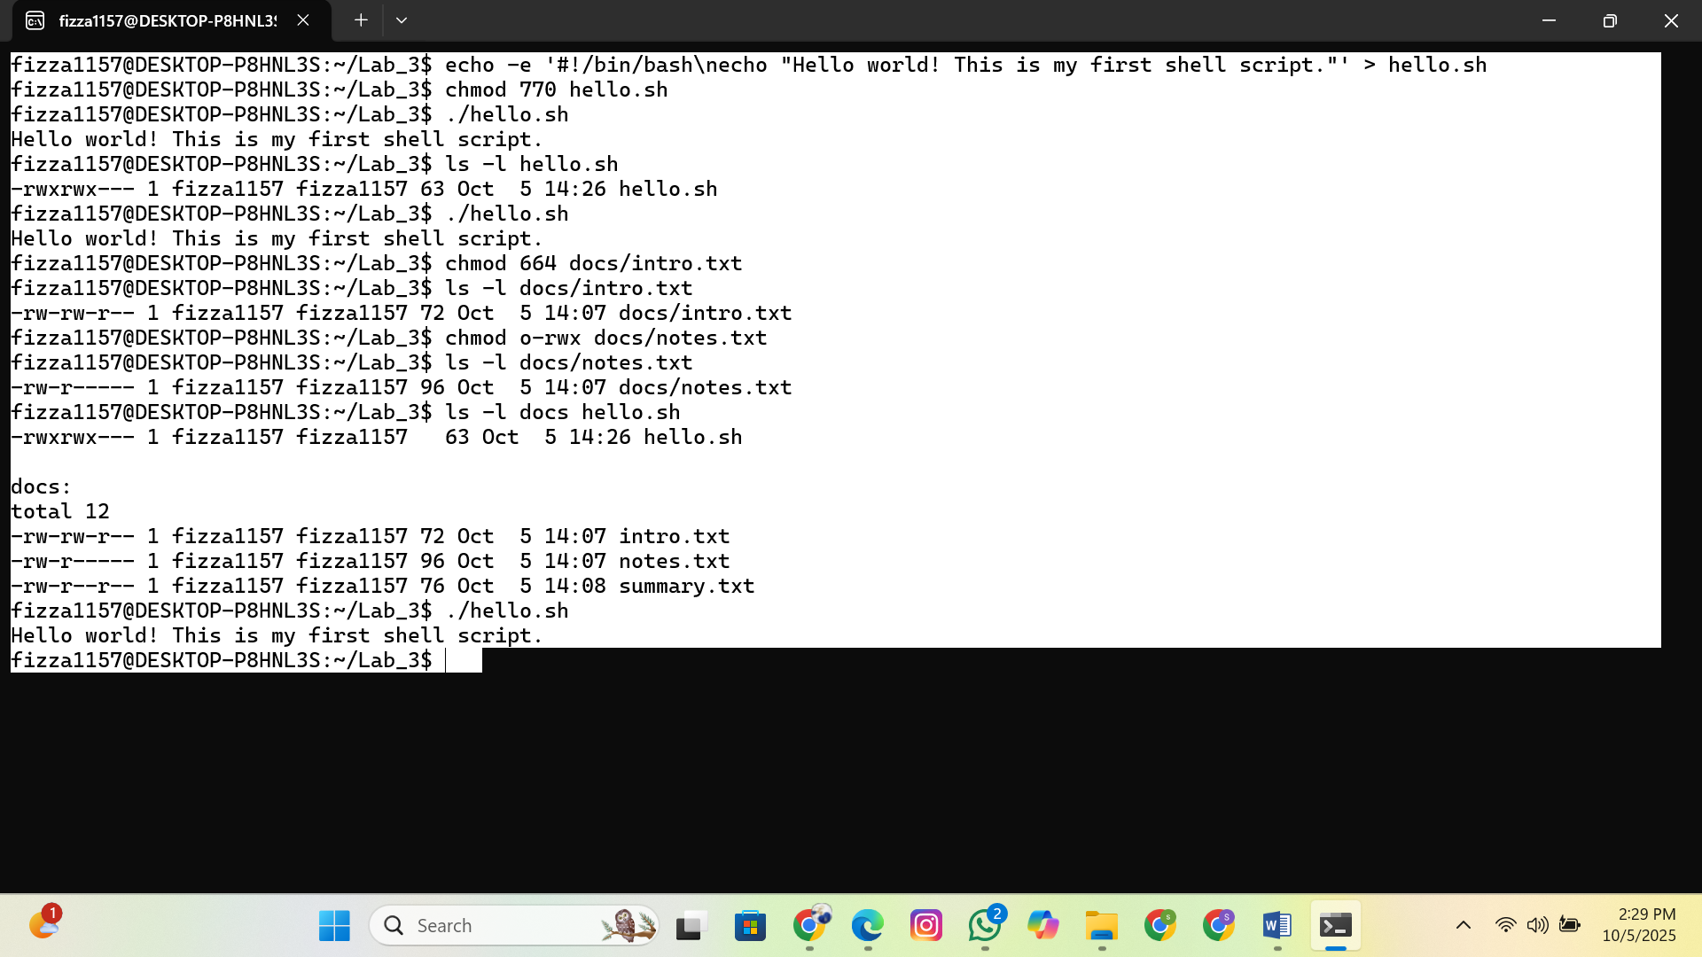

# Part 4: Reading & Searching Files

Inside docs/ :

1. Count the number of lines, words, and characters in notes.txt using wc .
2. Show only the **first 2 lines** of summary.txt using head -n 2 .
3. Show the **last line** of summary.txt using tail -n 1 .
4. Search for a keyword (of your choice) in intro.txt using grep .

Take screenshots.

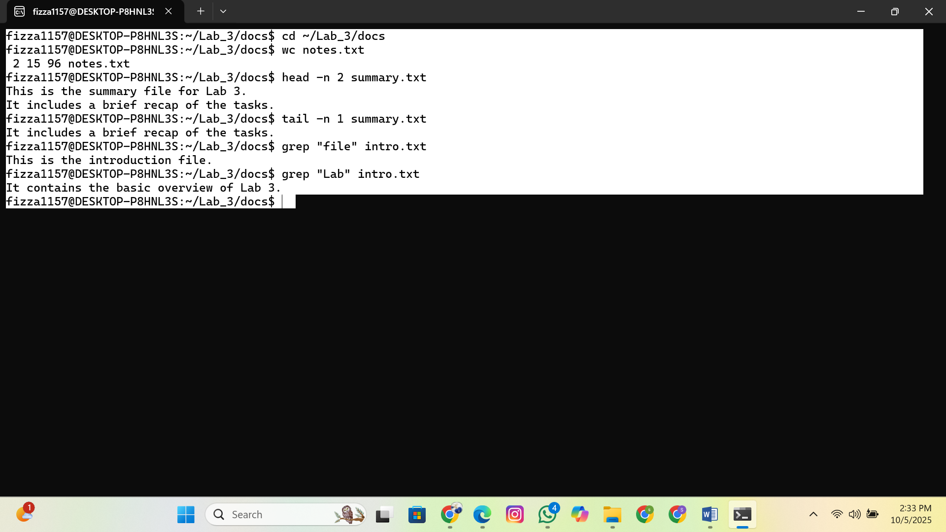

# Part 5: Linux Process Commands

## 1. Exploring Processes

Use ps -ef and identify **3 processes** running on your system. Note their **PID, PPID, and command**.

Run top for 20–30 seconds. Write down:

Which process is consuming the most CPU.

Which process is consuming the most memory.

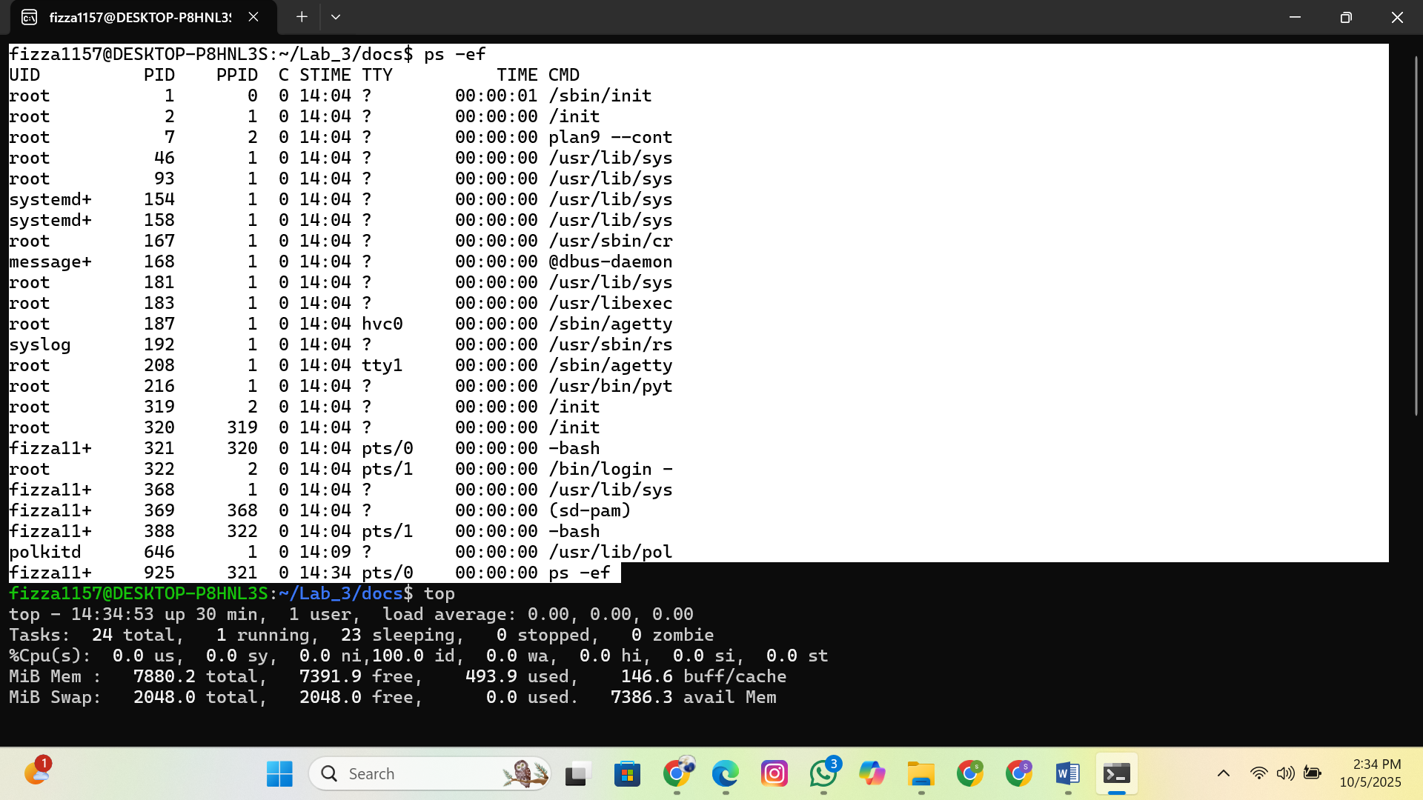

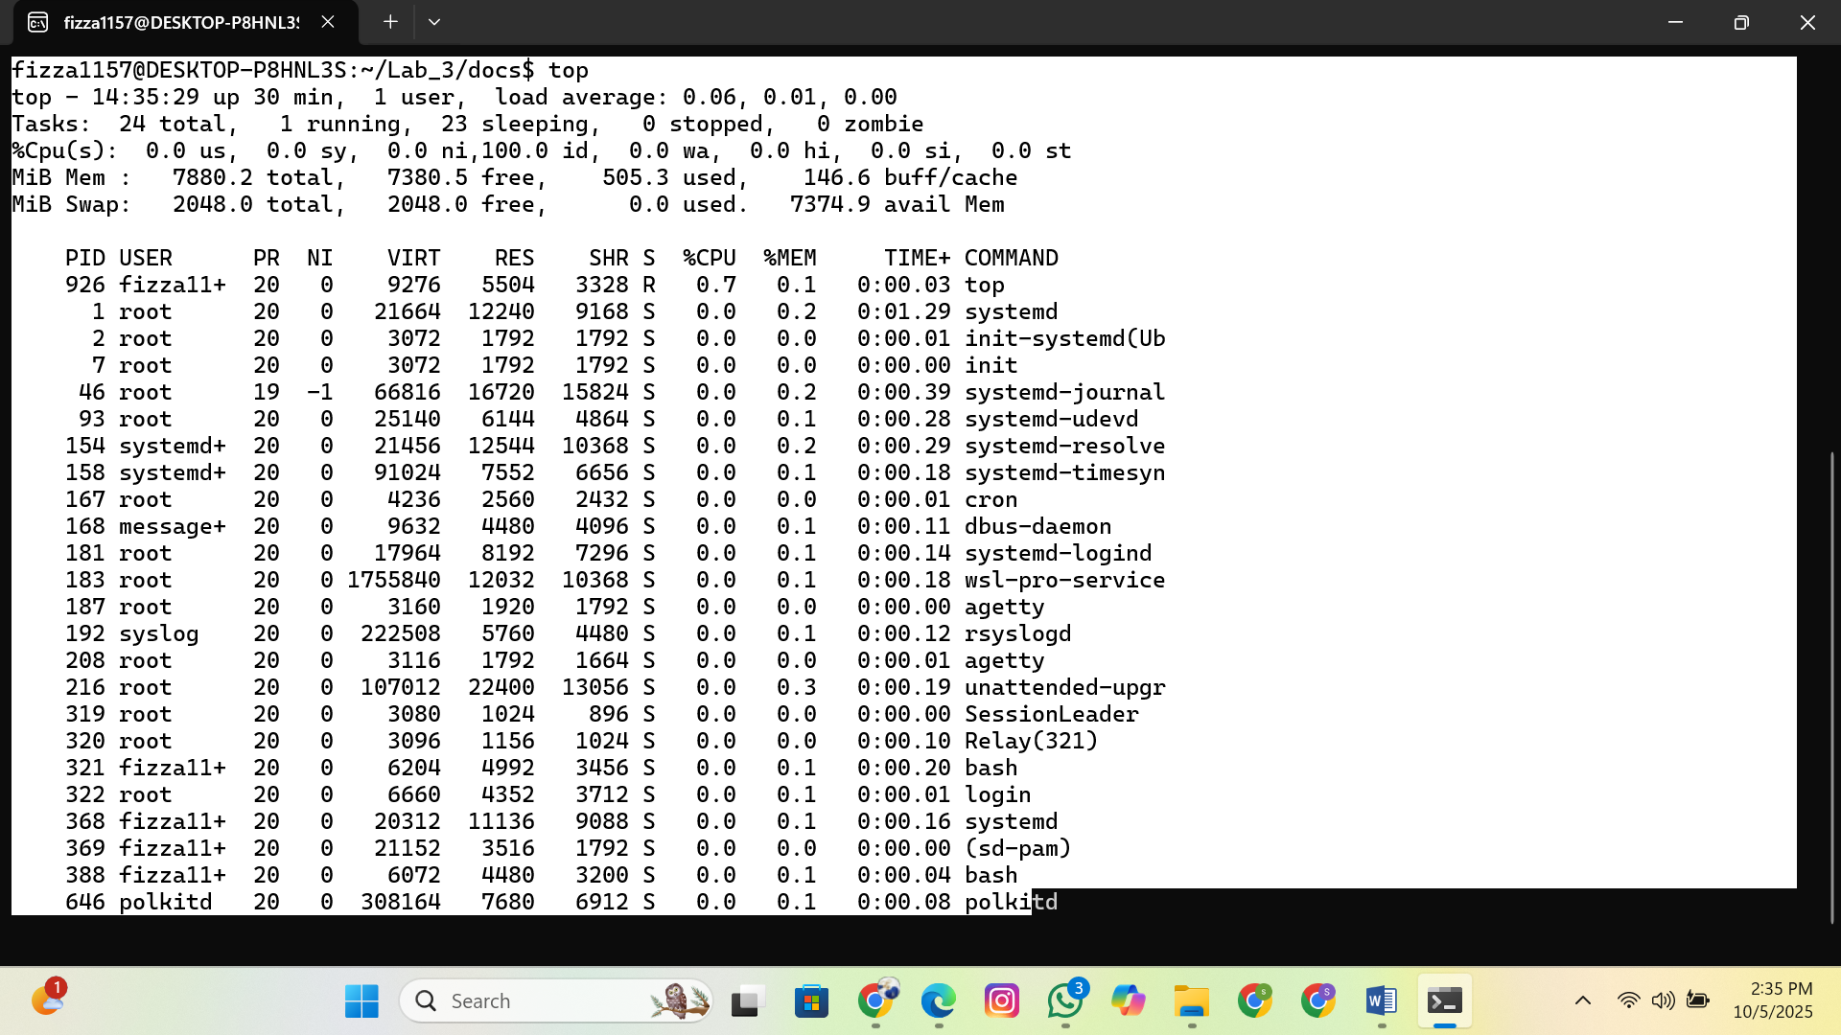

## 2. Practice with Infinite Process

Start:

yes

>

/

dev

/

null

&

Locate its PID using

ps

-

ef

|

grep

yes

.

Kill it using

kill

<

PID

>

and verify using

ps

.

3

.

**Foreground & Background Jobs**

Run

sleep

60

in

**foreground**

and terminate it with

**Ctrl + C**

.

Run

sleep

60

&

in

**background**

, bring it to foreground with

fg

, stop with

**Ctrl + Z**

,

then resume in background using

b

g

.

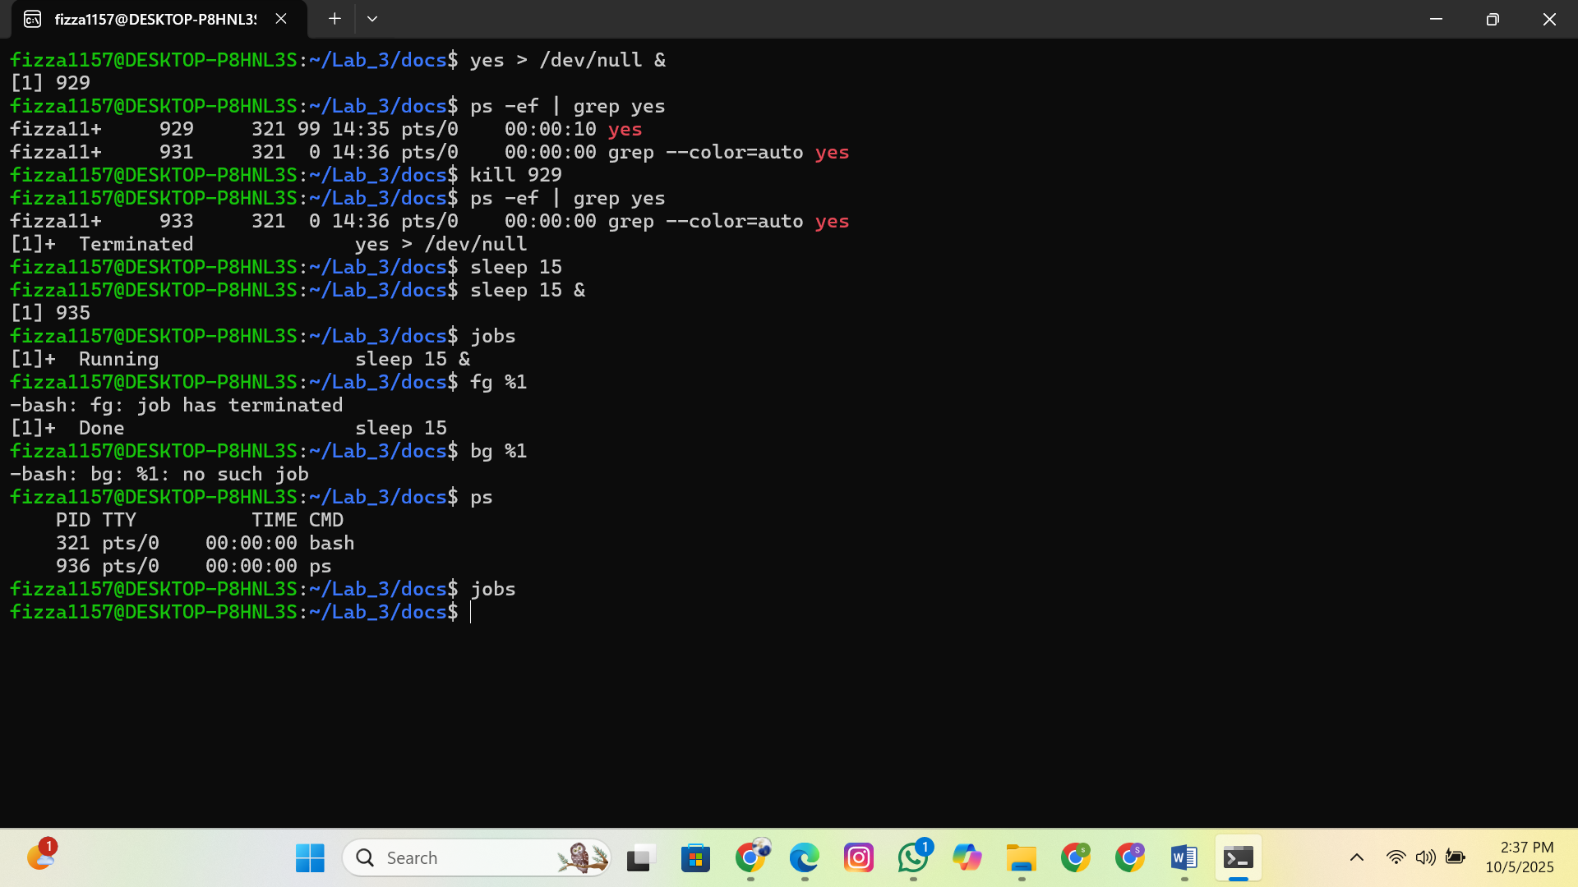

# Part 6: C Programs on Processes

**Program 1 – Exec with top**

Modify the exec program so that the child runs **top** instead of ls -l .

Run the program.

In another terminal, use ps -ef | grep top (or run top ) to find the child’s PID.

Use the child's process ID to kill it manually.

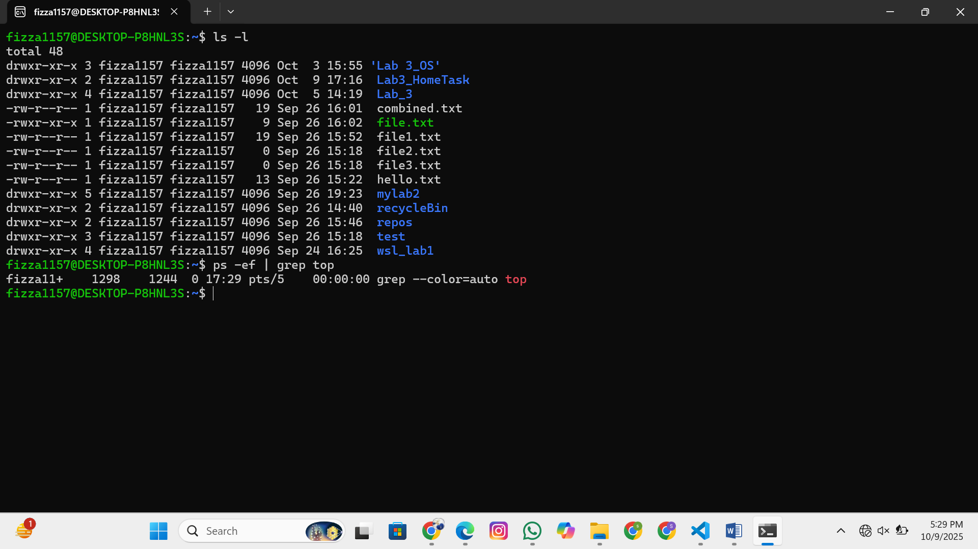

**Program 2 – Incomplete Program**

#

in

c

lude

<

stdio

.

h

>

#

in

c

lude

<

unistd

.

h

>

#

in

c

lude

<

sys

/

w

a

it

.

h

>

int

m

a

in

(

)

{

pid

_

t

pid

=

fork

(

)

;

if

(

pid

==

0

)

{

//

TODO

:

R

epl

ac

e

this

c

hild

pro

c

ess

with

the

"

d

a

te

"

c

omm

a

nd

using

exe

c

lp

//

H

int

:

exe

c

lp

(

"

d

a

te

", "

d

a

te

",

NULL

)

;

}

else

{

//

TODO

:

Ma

ke

p

a

rent

w

a

it

for

c

hild

b

efore

printing

"

C

hild

finished

"

}

return

0

;

}

**Task:** Complete the missing parts, run the program, and take a screenshot of the output.

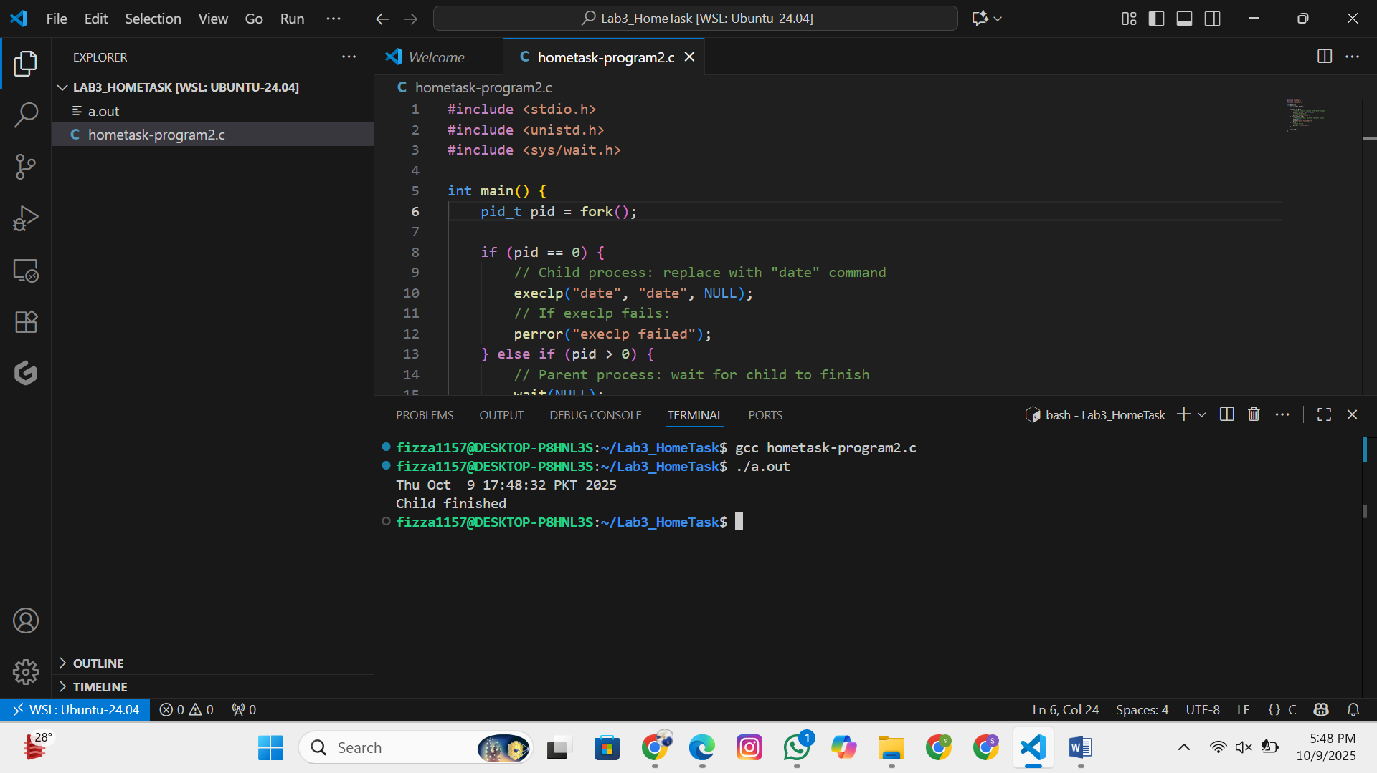

# Submission Guidelines

Submit a **single PDF file** including:

Screenshots of all said commands & outputs.

Modified & completed C program code and outputs.

**Deadline:** 9th October, 2025, 11:59 PM.